**ASSESSMENT FOR**

**ITICOR0021A - Apply Occupational Health and Safety Procedures**

**ITICOR0231A - Operate A Personal Computer**

**ITINET1111A - Operate Peripherals Devices**

**ASSESSMENT – Research**

**TOPIC (GENERAL):** Apply Occupational Health and Safety Procedures

**TASK:** Identify Types of Safety Equipment for an Information and

Communication Industry

The principle of Occupational Health and Safety is that employers must provide a safe and

healthy environment for their employees. Prepare in Microsoft Word a document to show types

of safety signs and equipment used within an Information and Communication workplace.

1. Complete the task by creating a document in Microsoft Word to display the following safety equipment and signs below.

**Safety Equipment**

* Fire Extinguishers
* Fire Alarms
* Smoke Detectors
* Burglar Alarms
* Non-Skid Mats
* Door Chains
* Electronic Locks

**Safety Signs**

* No food or drink
* No smoking
* No entry authorized personnel only
* Exit
* No Running
* Keep work area tidy
* Shut down computer after use
* Do not overload electrical sockets
* Surf safely
* Electrical Hazard
* Slippery Surface
* First Aid
* Emergency Assembly Point
* Social Distancing
* Sanitize Hands
* Wear Face Mask

1. Provide a picture of each safety equipment and safety signs. Each picture should be appropriately place on the page.
2. State the use of each safety equipment and safety signs.

**The following checklist will be used to assess this assignment.**

**Points will be assigned with the following values:**

**The total score will be 50 marks. A total of 23 marks for Content, 4 marks for Design and Layout and 23 marks for Graphics.**

**You must obtain at least 30 out of 50 (60%) to be deemed competent. If you score less, you will be deemed not yet competent and will have to repeat the assignment.**

|  |  |  |  |  |  |  |  |  |  |  |  |  |  |  |  |  |  |  |  |  |  |  |  |  |  |  |  |  |  |  |  |  |  |  |  |  |  |  |  |  |  |  |  |  |  |  |  |  |  |  |  |  |  |  |  |  |  |  |  |  |  |  |  |  |  |
| --- | --- | --- | --- | --- | --- | --- | --- | --- | --- | --- | --- | --- | --- | --- | --- | --- | --- | --- | --- | --- | --- | --- | --- | --- | --- | --- | --- | --- | --- | --- | --- | --- | --- | --- | --- | --- | --- | --- | --- | --- | --- | --- | --- | --- | --- | --- | --- | --- | --- | --- | --- | --- | --- | --- | --- | --- | --- | --- | --- | --- | --- | --- | --- | --- | --- |
| **EVALUATION CHECKLIST**   |  |  |  |  | | --- | --- | --- | --- | | **Title: Safety Equipment Used Within an Information and Communication Workplace** | | | | | **Criteria** | **Allotted Grade** | **Grade obtained** | ***Notes****(how this could be improved?)* | | **CONTENT** |  |  |  | | Function of each safety equipment | **7** |  | | Function of each safety sign | 16 |  | | **TOTAL** | **23** |  | |  | | | | **DESIGN AND LAYOUT** |  |  |  | | Alignment of picture and text on page | **1** |  | | Name of each equipment and sign is clearly stated | **1** |  | | Appropriate use of fonts and color usage | **1** |  | | Head page 1 appropriately including student name | **1** |  | | **TOTAL** | **4** |  | |  | | | | **GRAPHICS** |  |  |  | | Appropriate clipart or picture for each safety equipment | **7** |  | | Appropriate clipart or picture for each safety sign | 16 |  | | **TOTAL** | **23** |  | | **Overall Total** | **50** |  |  | |  |  |

**Candidate Signature:** ______________________________ **Date:** ________________

**Assessor Signature:** ______________________________ **Date:** ________________

**Internal Verifier Signature:** ___________________________ **Date:** ________________

*(Only if task is an internal verficiation assessment)*

**Safety Equipment**

* **Fire Extinguishers**

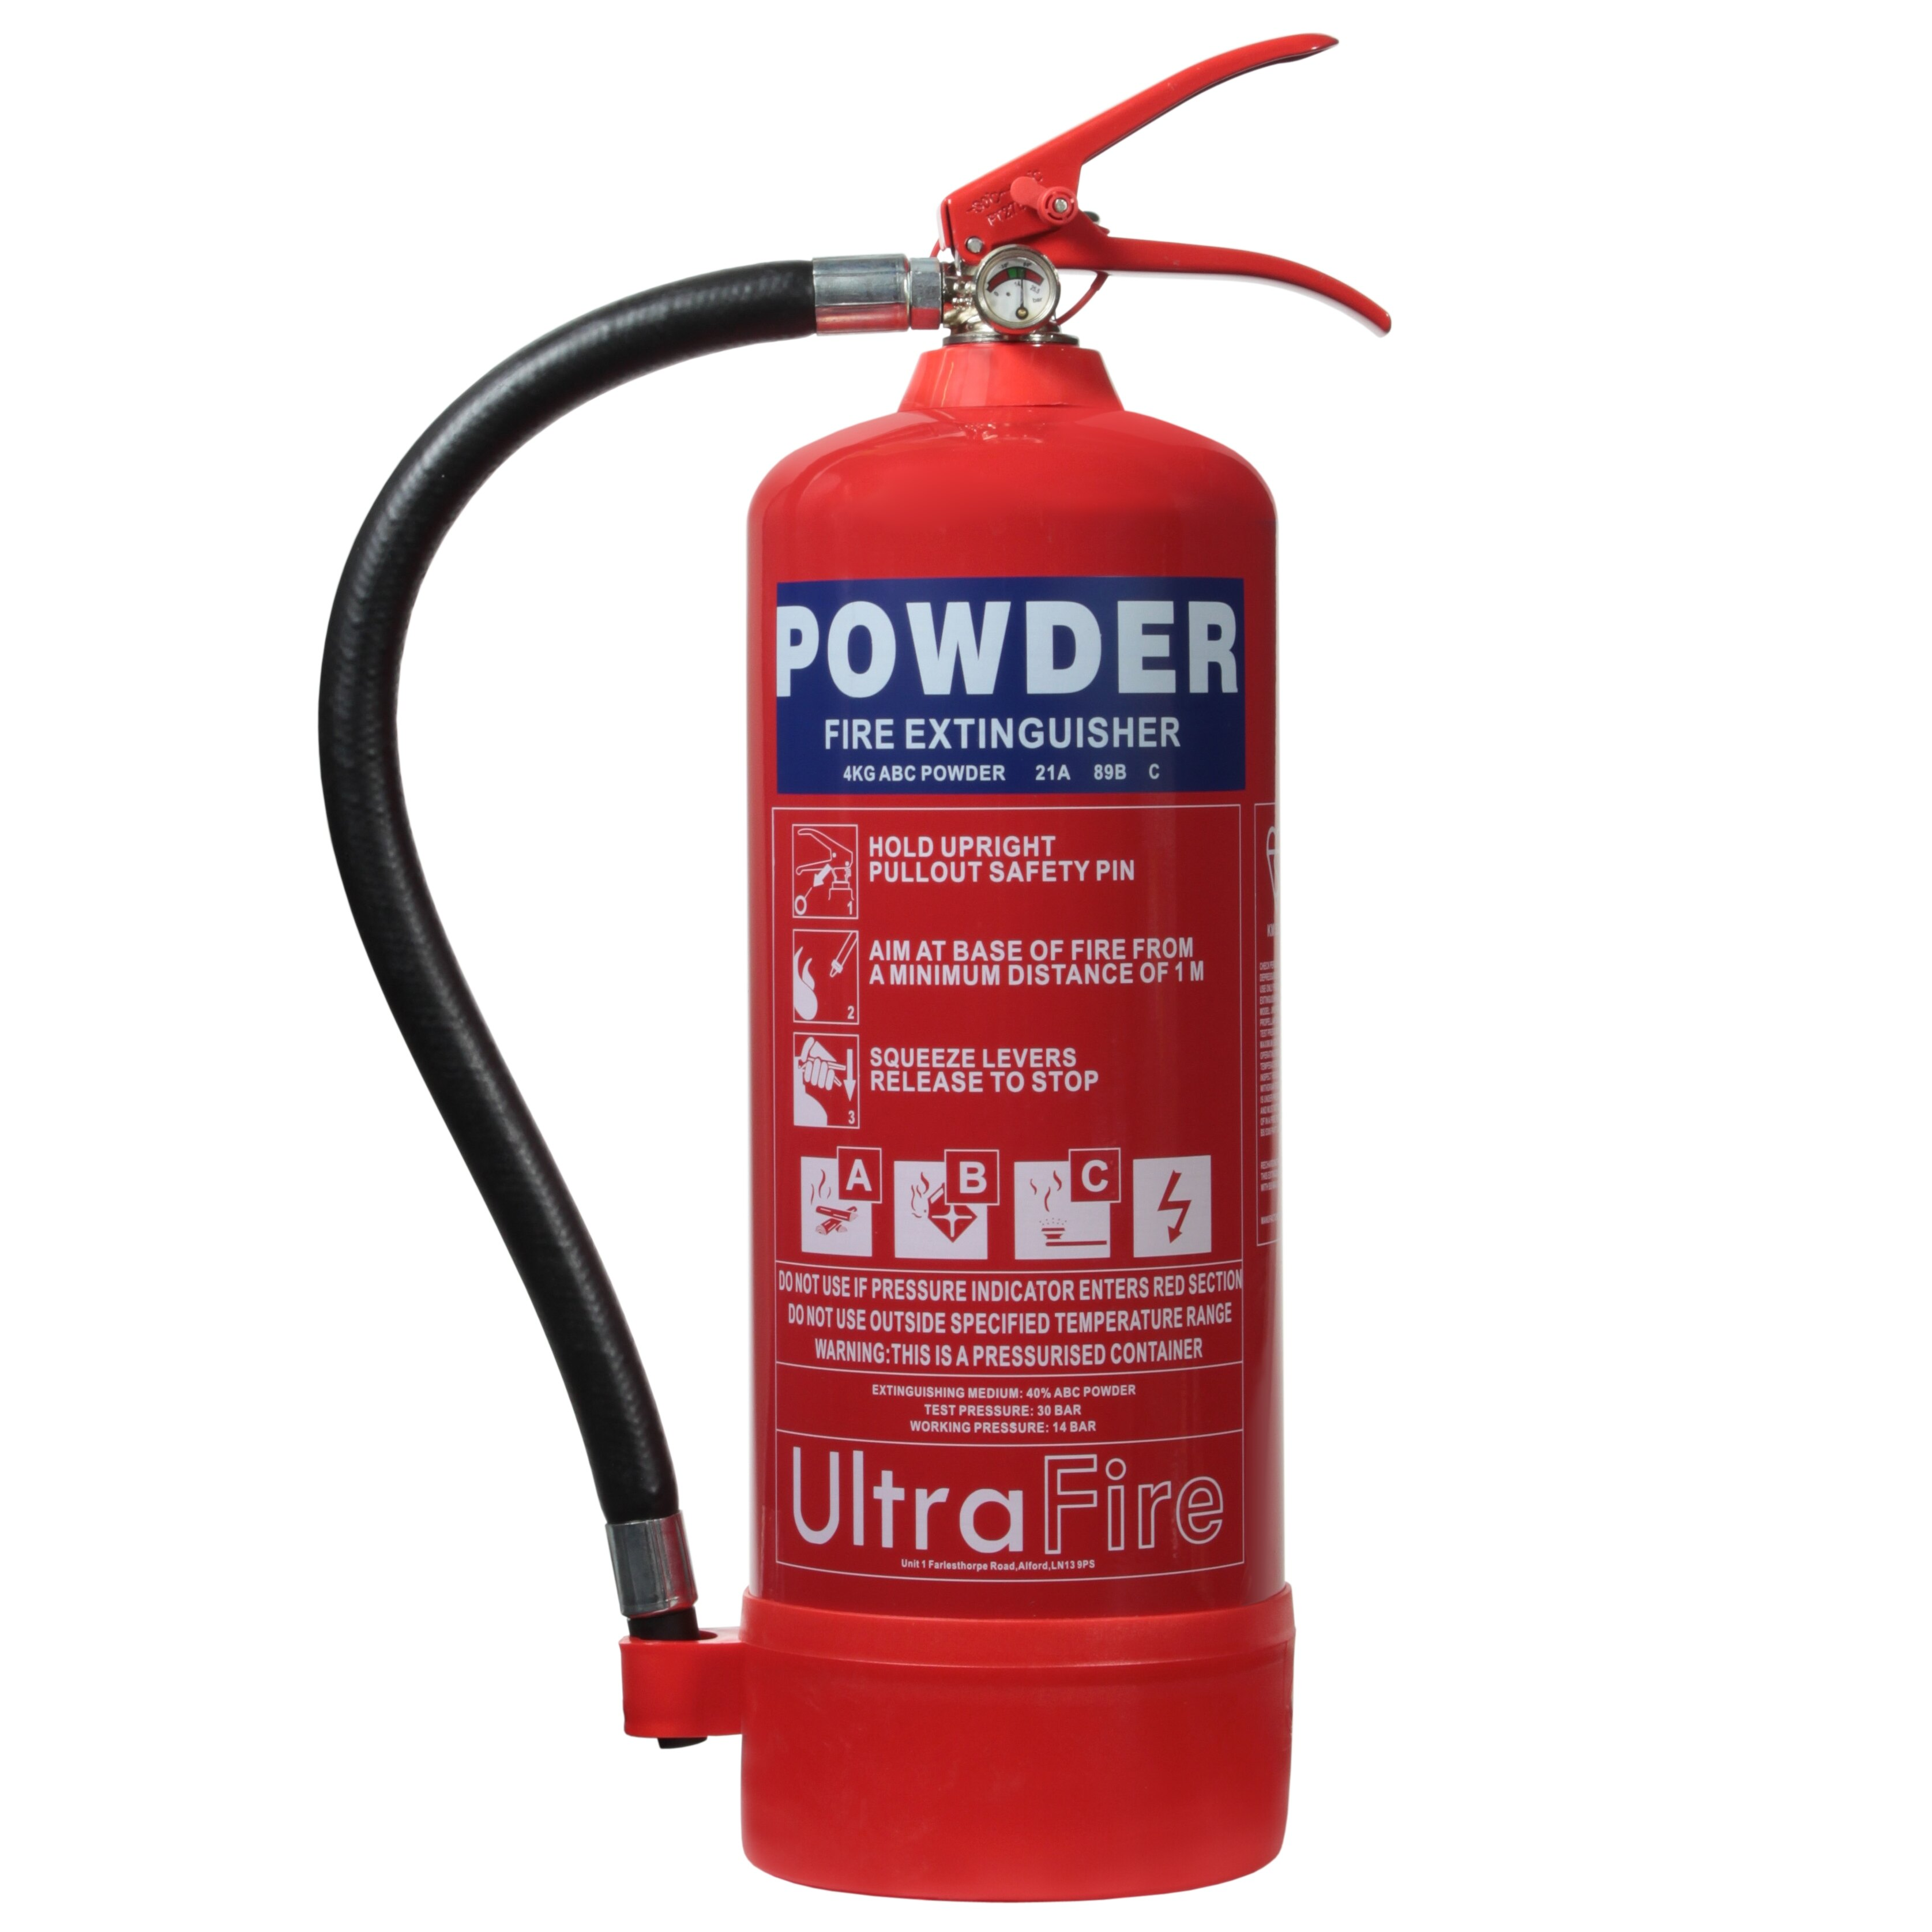

* To put out small fires or control them until professional help arrives. They are categorized by types of fires (e.g., electrical, grease).

**Fire Alarms**

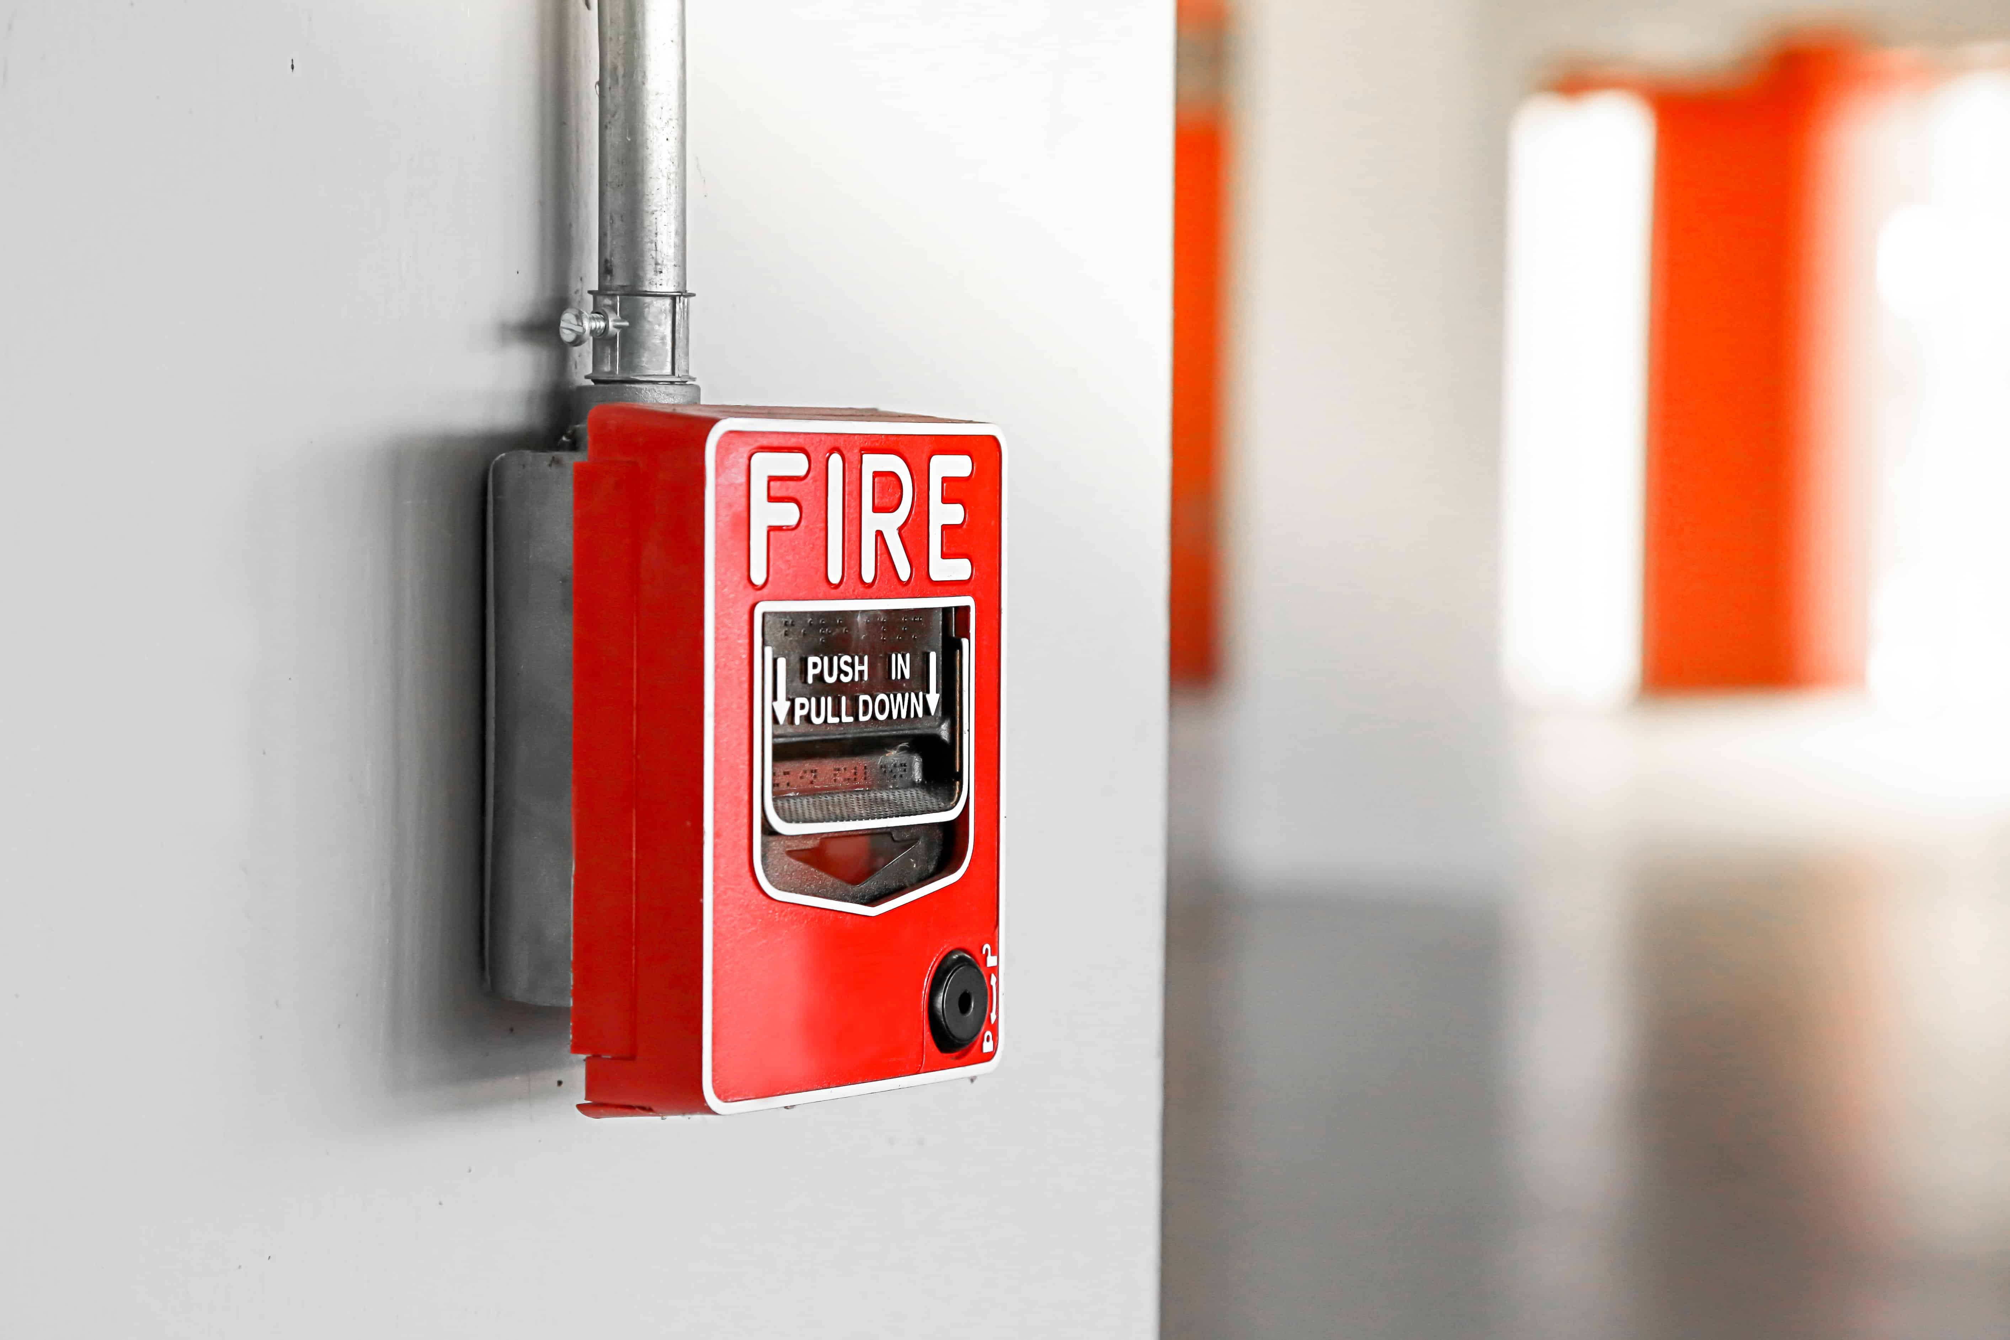

* To detect smoke or fire and alert occupants of a building, allowing for timely evacuation and response.

**Smoke Detectors**

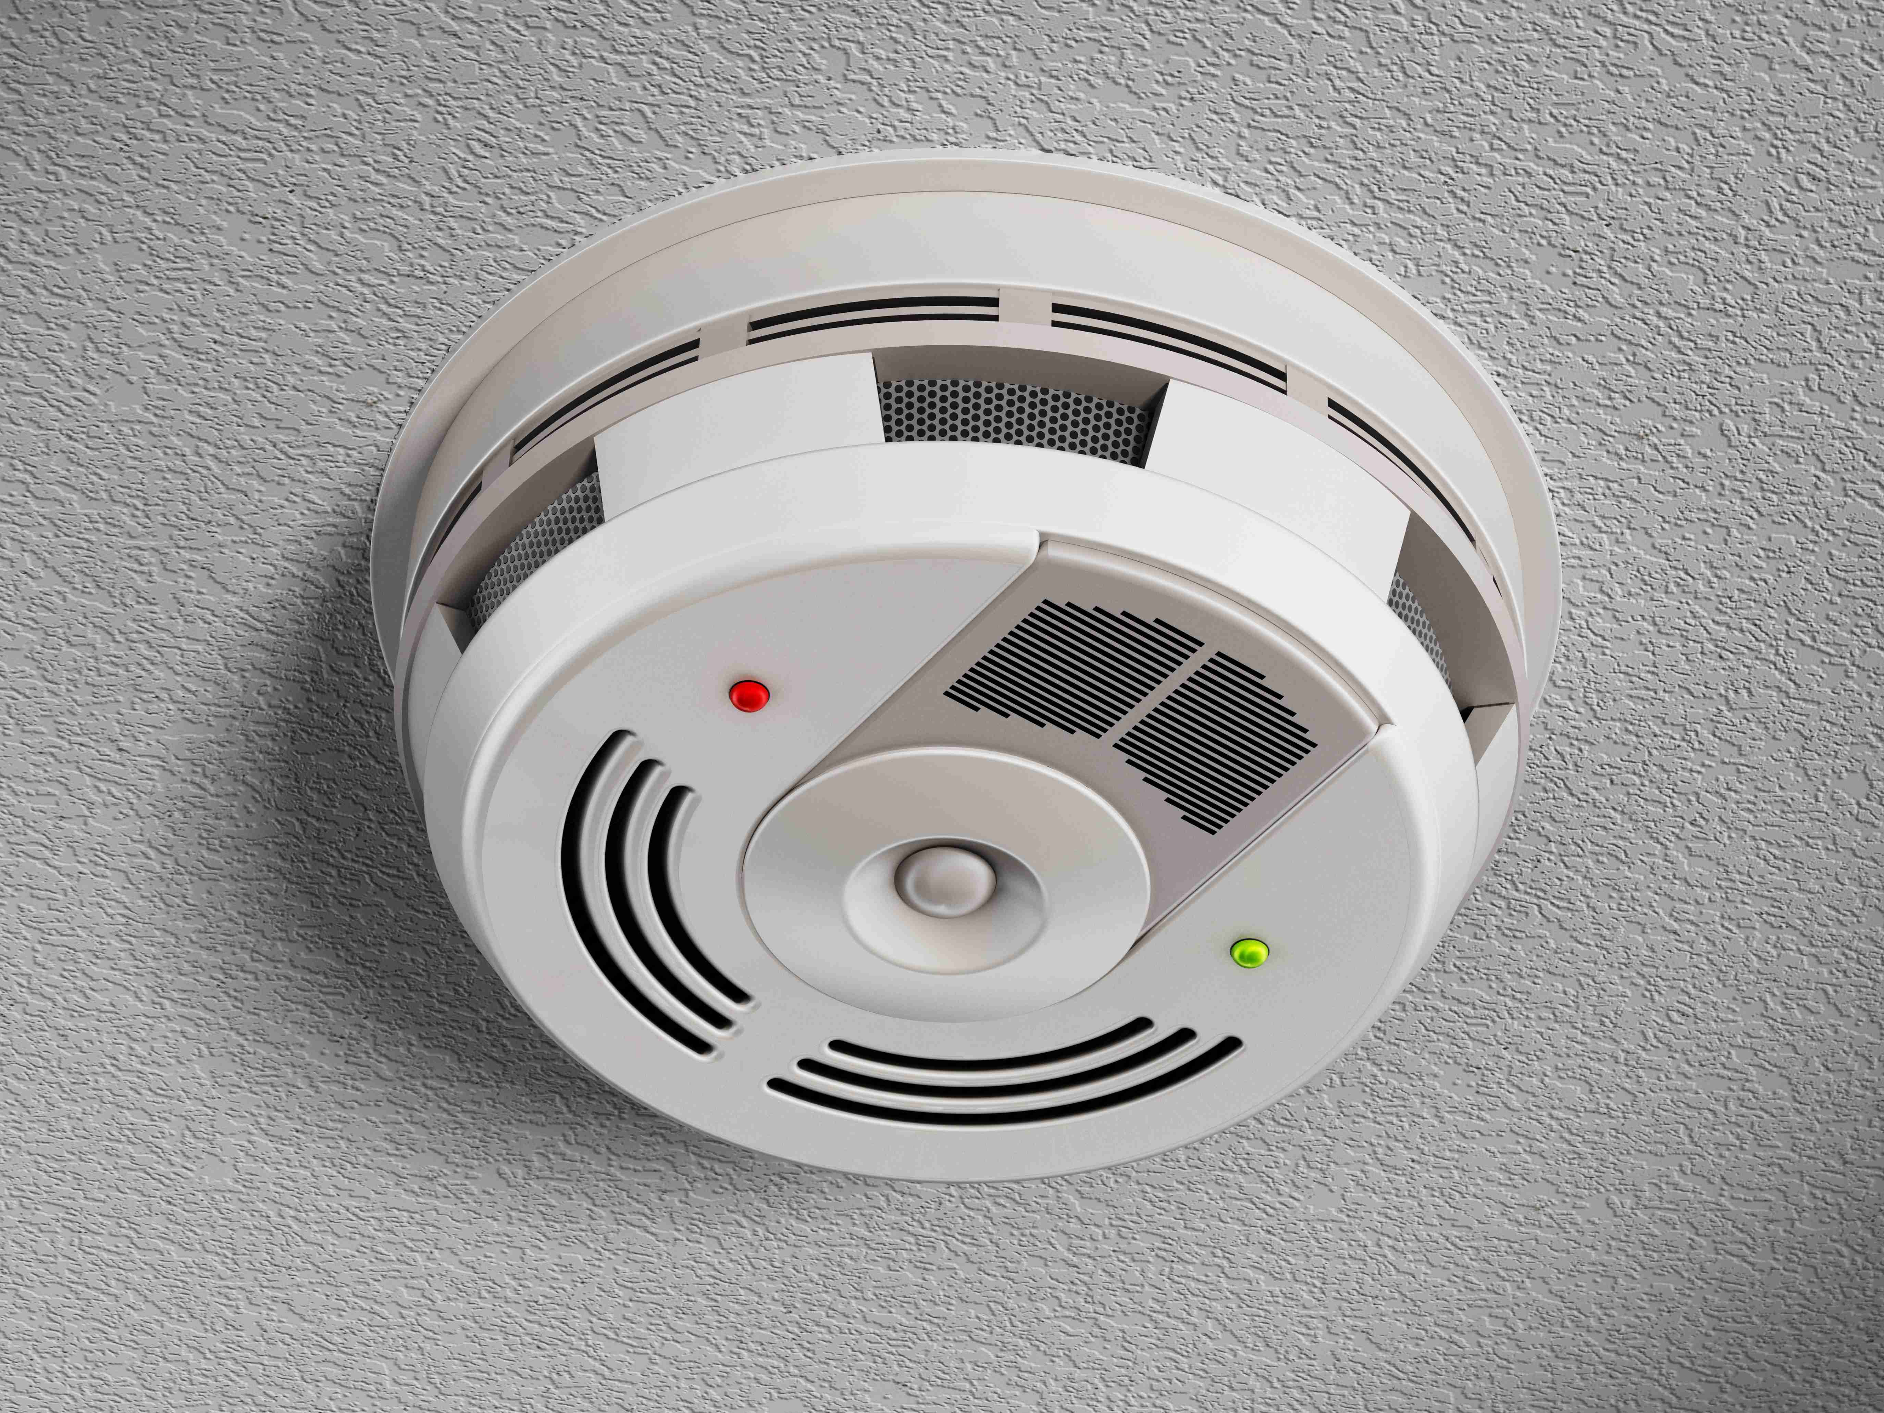

* To detect the presence of smoke, typically as a sign of fire. They emit an alarm to warn occupants.

**Burglar Alarms**

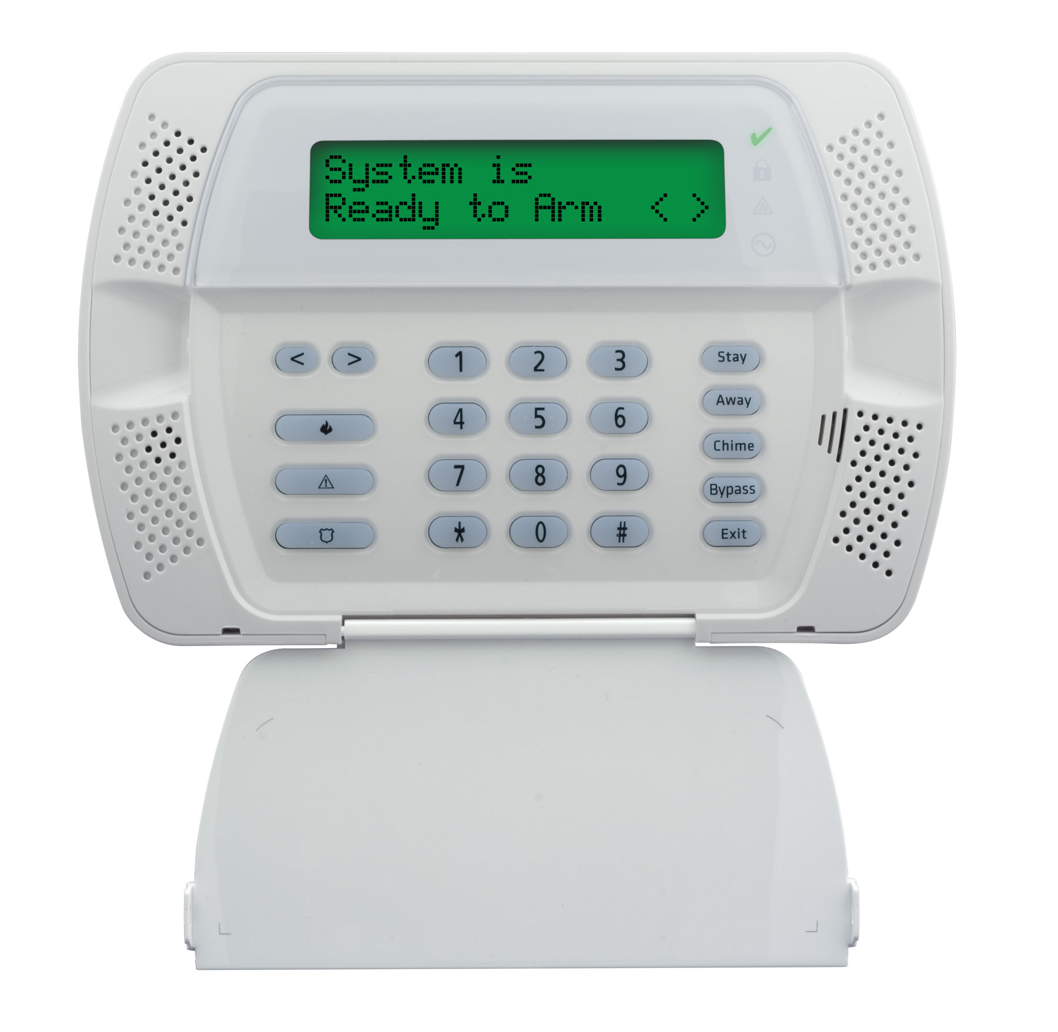

* To alert homeowners and authorities of unauthorized entry or intrusion into a property, enhancing security.

**Non-Skid Mats**

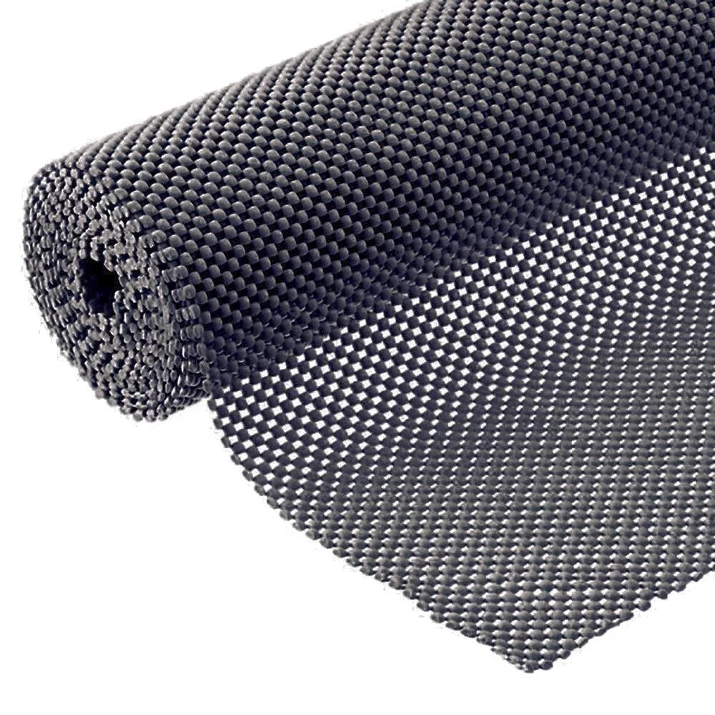

* To provide traction and prevent slips and falls, especially in areas prone to moisture or spills.

**Door Chains**

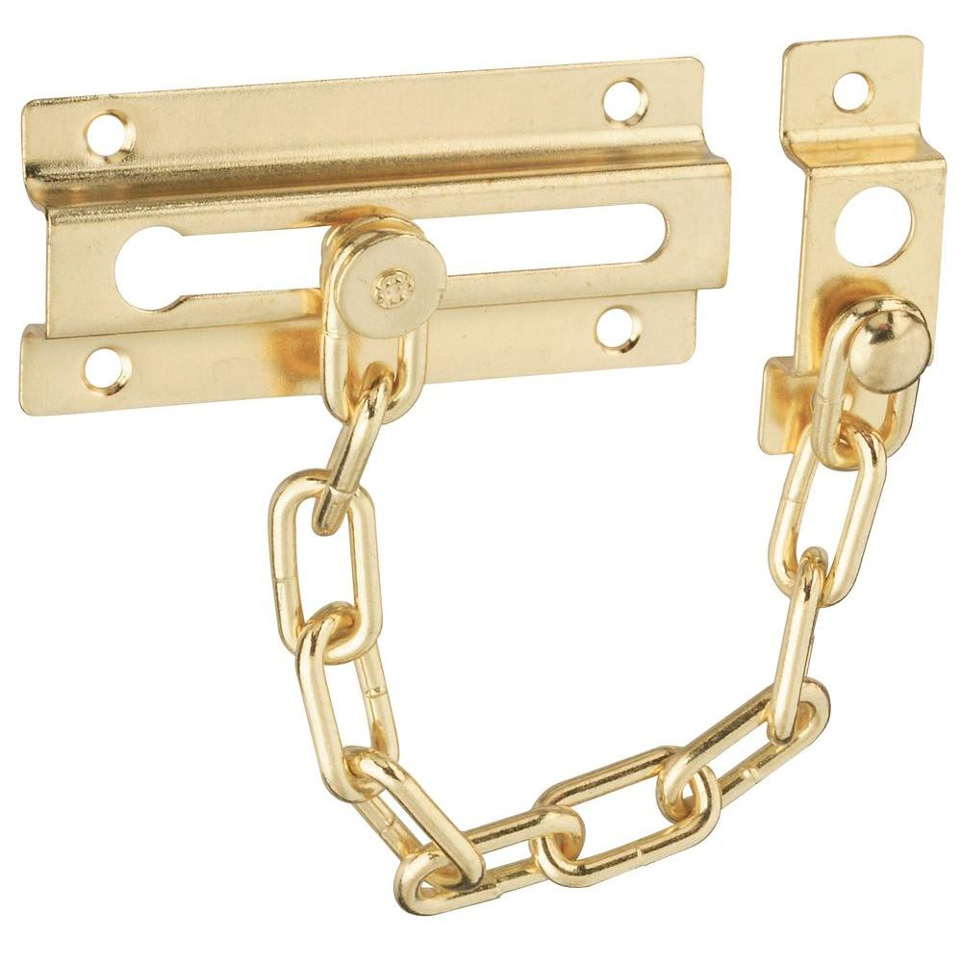

* To provide an additional layer of security, allowing doors to be opened slightly for identification while preventing full access.

**Electronic Locks**

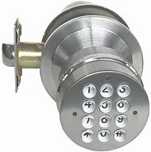

* To secure doors with electronic keypads or biometric scanners, offering advanced security options and convenience.

**Safety signs**

**No Food or Drink**

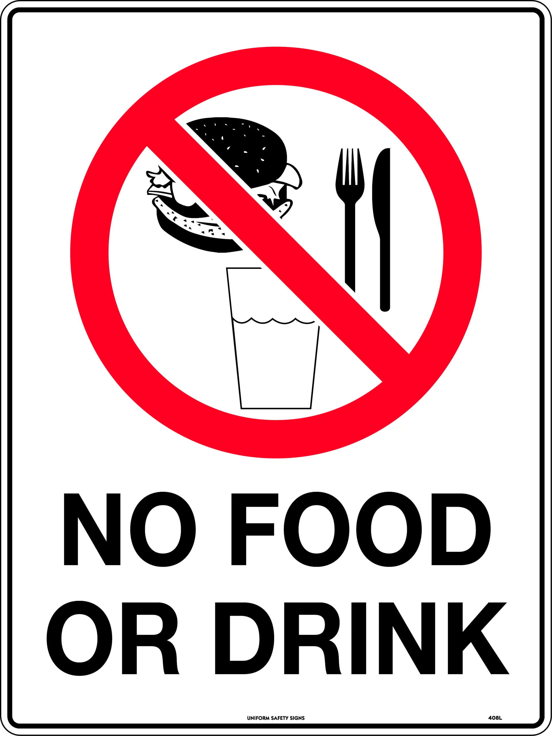

* To prevent spills and pests in work areas, maintaining cleanliness and safety.

**No Smoking**

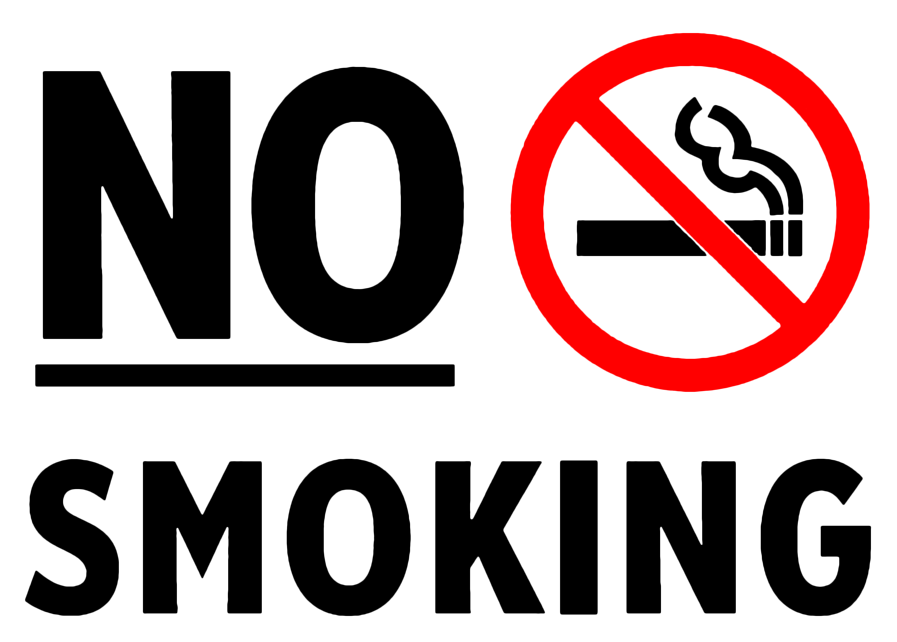

* To reduce fire risks and promote a healthier environment by prohibiting tobacco use indoors or in designated areas.

**No Entry Authorized Personnel Only**

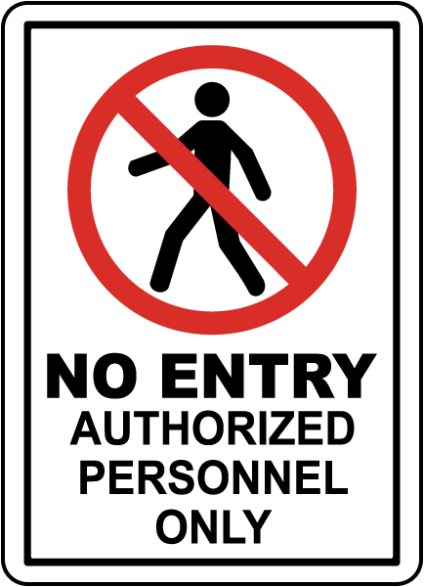

* To restrict access to specific areas, ensuring safety and confidentiality by allowing only trained individuals.

**Exit**



* To indicate the location of emergency exits, facilitating safe evacuation during emergencies.

**No Running**

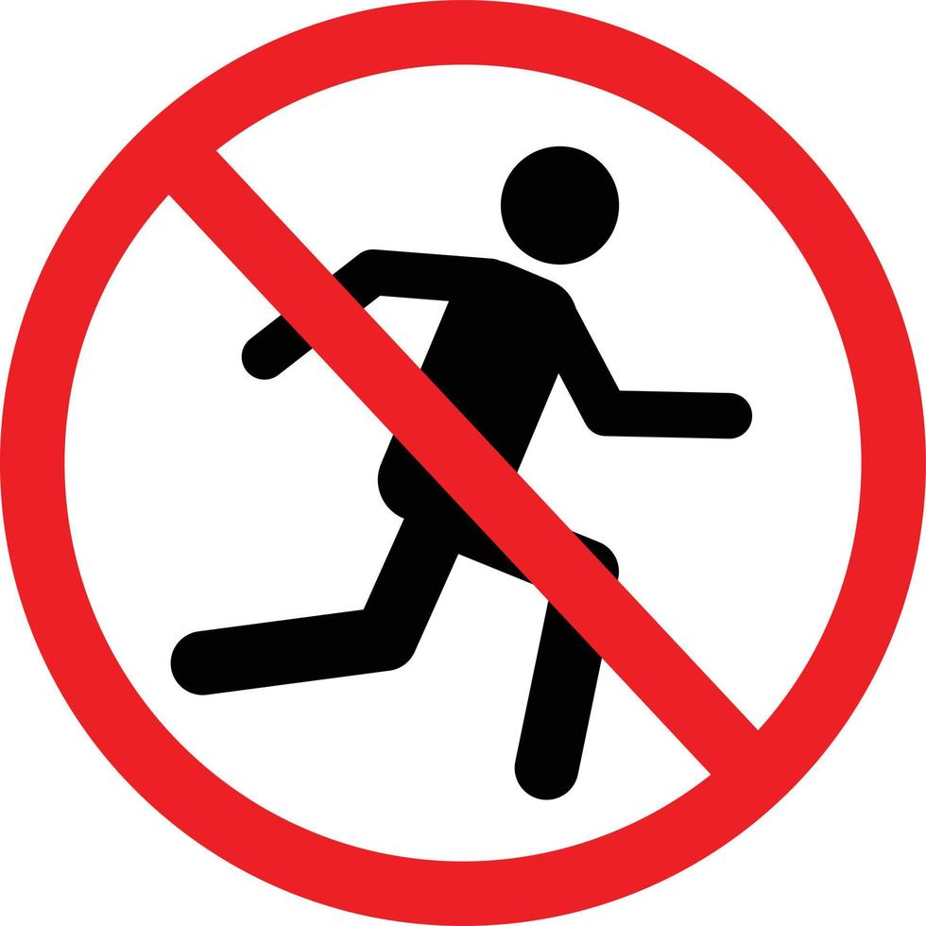

* To prevent accidents and injuries in areas where slipping or falling is likely.

**Keep Work Area Tidy**

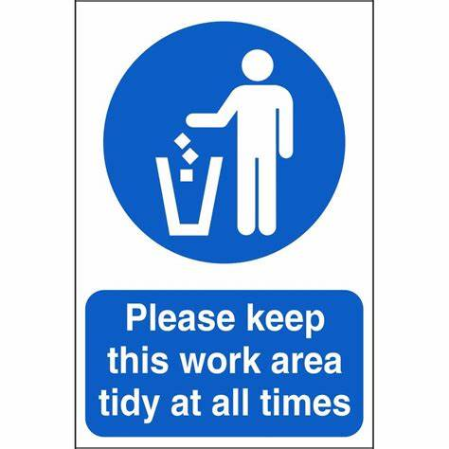

* To promote organization and safety, reducing the risk of accidents caused by clutter.

**Shut Down Computer After Use**



* To conserve energy and protect equipment, ensuring that computers are properly turned off.

**Do Not Overload Electrical Sockets**

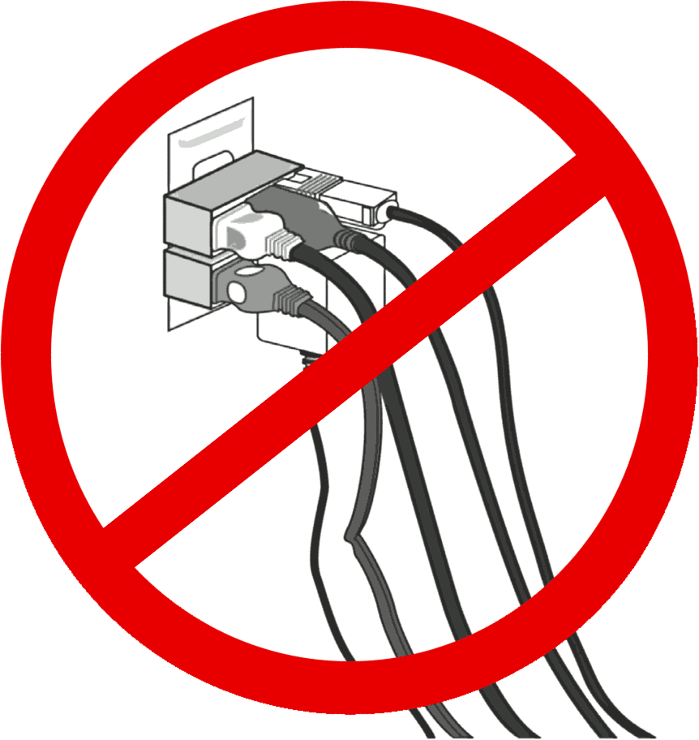

* To prevent electrical fires and equipment damage by avoiding overloading circuits.

**Surf Safety**

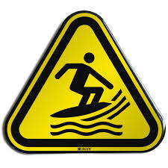

* This involves being cautious while using the internet, such as avoiding suspicious links and ensuring personal data is protected, to prevent cyber threats.

**Electrical Hazard**

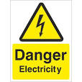

* Awareness of potential electrical hazards helps prevent accidents like shocks or fires. Always ensure equipment is in good condition and used properly.

**Slippery Surface**

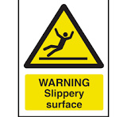

* This warns of areas that may cause slips and falls. Keeping these surfaces clear and marked can help prevent injuries.

**First Aid**

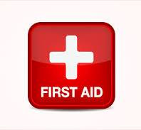

* Knowledge of basic first aid can be critical in emergencies, allowing for immediate care of injuries before professional help arrives.

**Emergency Assembly Point**

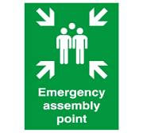

* Designating a clear assembly point helps ensure everyone knows where to gather in case of an evacuation, enhancing safety during emergencies.

**Social Distancing**

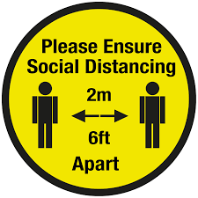

* This practice helps reduce the spread of infectious diseases by maintaining physical distance between individuals, especially in crowded settings.

**Sanitize Hands**

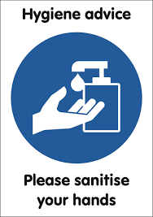

* Regular hand sanitation helps prevent the spread of germs and infections, promoting overall health and safety, especially in communal environments.

**Wear Face Mask**

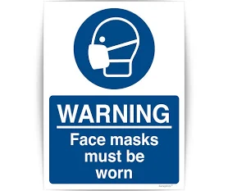

* Masks help block respiratory droplets that may contain viruses or bacteria, reducing the risk of transmission, especially in crowded or enclosed spaces.